Android Mobile App Instrumentation Procedure

#Step1 & 2:
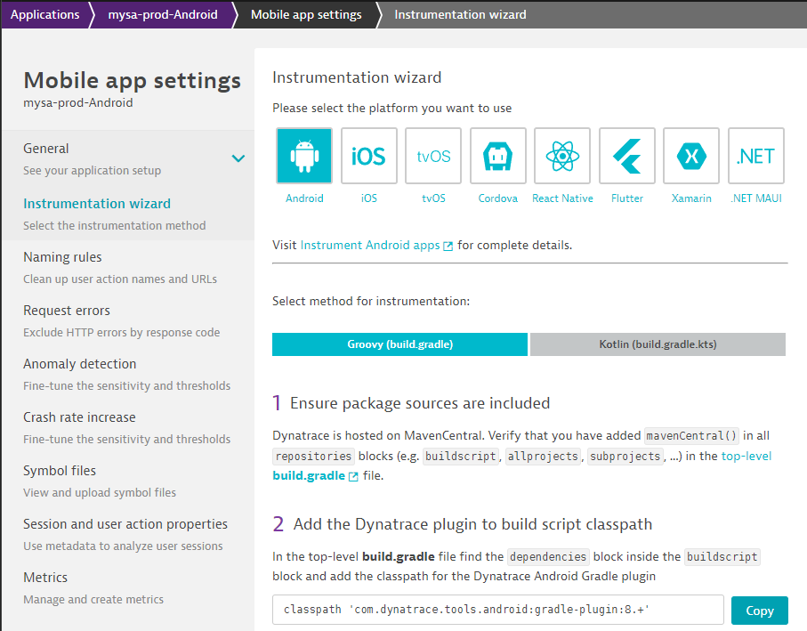
classpath 'com.dynatrace.tools.android:gradle-plugin:8.+'

#Step3 & 4 & 5:
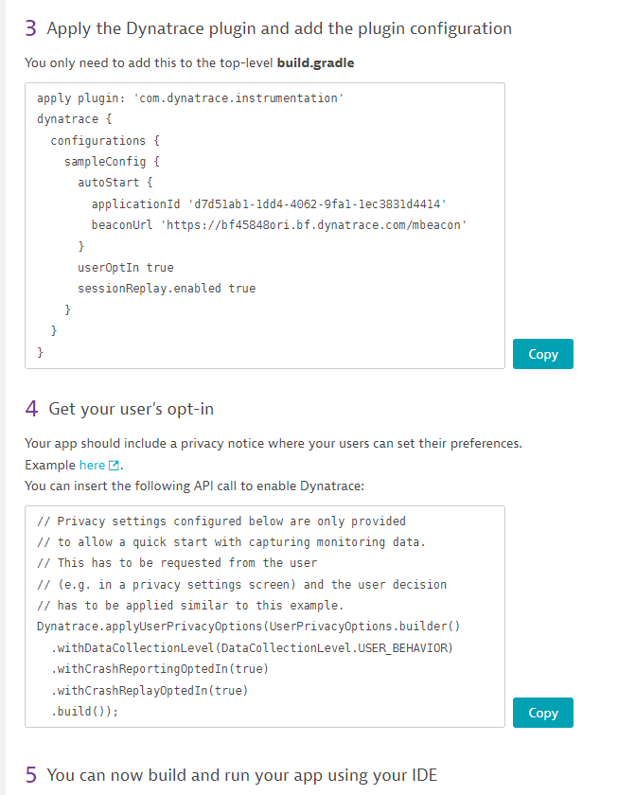
apply plugin: 'com.dynatrace.instrumentation'
dynatrace {
configurations {
sampleConfig {
autoStart {
applicationId 'd7d51ab1-1dd4-4062-9fa1-1ec3831d4414'
beaconUrl 'https://bf45848ori.bf.dynatrace.com/mbeacon'
}
userOptIn true
sessionReplay.enabled true
}
}
}
Get your user's opt-in
// Privacy settings configured below are only provided
// to allow a quick start with capturing monitoring data.
// This has to be requested from the user
// (e.g. in a privacy settings screen) and the user decision
// has to be applied similar to this example.
Dynatrace.applyUserPrivacyOptions(UserPrivacyOptions.builder()
.withDataCollectionLevel(DataCollectionLevel.USER_BEHAVIOR)
.withCrashReportingOptedIn(true)
.withCrashReplayOptedIn(true)
.build());



